**Lecture: Complete Docker Installation on Multiple Platforms (CentOS/Red Hat)**

It is recommended not to install Docker from the general repository as it does not support the latest swarm

To install Docker Community Edition, we need to first install prerequisites packages

yum install –y yum-utils device-mapper-persistent-data lvm2

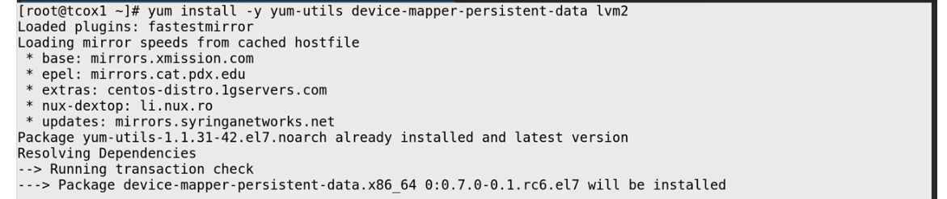

Now we need to configure the official Docker repository

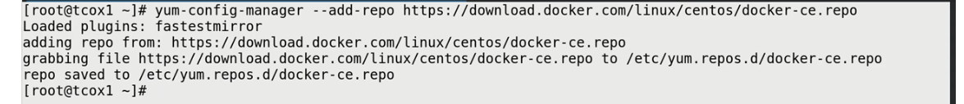

However we also need to update the yum repository

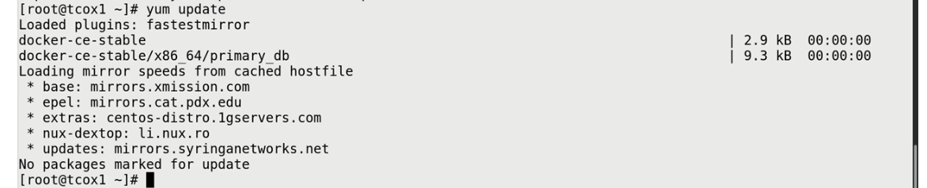

To install Docker Community Edition



This will also install all the dependencies. This may take time because of system selinux configuration

To start the Docker and enable to run on startup

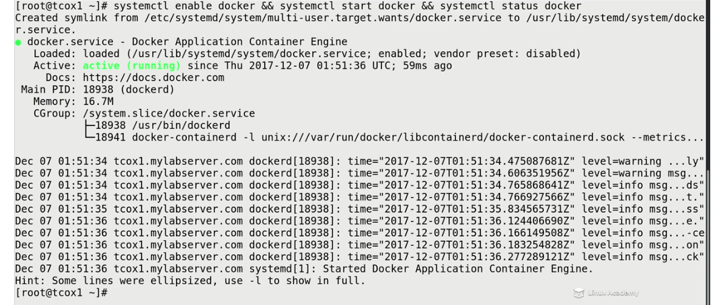

To run docker as non root user



Now Docker is ready to go to run as non-root user on Centos and RedHat

Total Time 10 minute

## Lecture: Complete Docker Installation on Multiple Platforms (Debian/Ubuntu)

To install Docker Community Edition, we need to first install prerequisites packages



Now we need to pull the gpg key to pull the official docker repository



Once pulled we can add the repository



Now we need to pull down docker cache

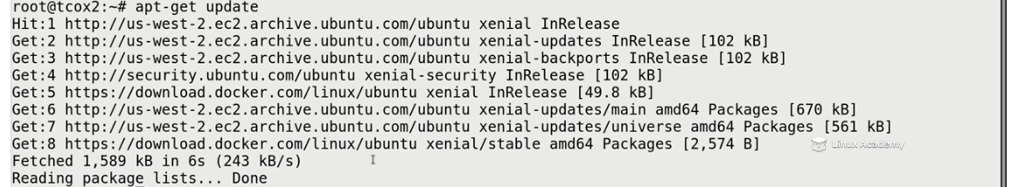

Now we install docker which will also install any depencies

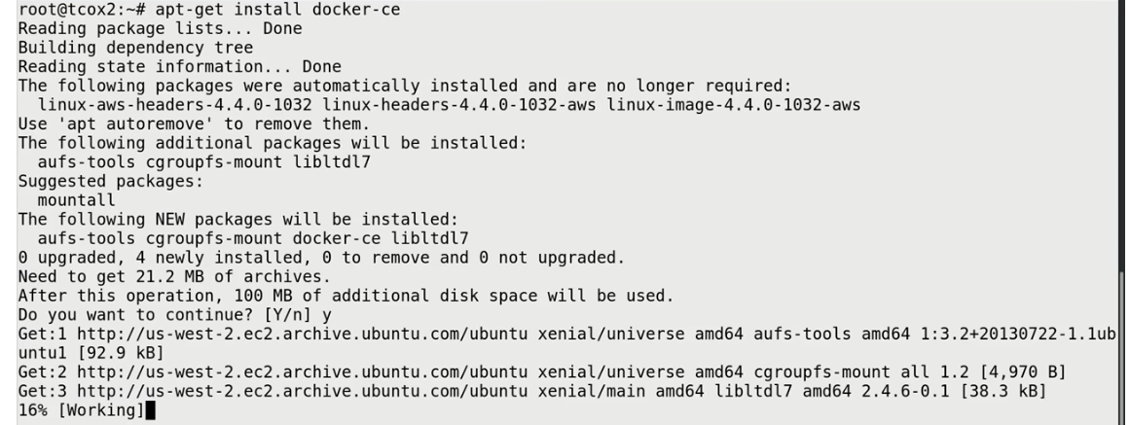

It is recommended to install on latest kernel version because it has process management version

In Ubuntu on install it will start the docker automatically

We need to make user a user can run docker



Total Time 10 minutes

## Lecture: Selecting a Storage Driver

Here we will understand how to select and configure a different storage driver for our system.

There are two ways to use a storage driver. One way is device-mapper and it is recommended since it is officially supported by docker. It can be used on a block storage since it uses a loop back adapter in order to provide that. If you run docker info, it will tell which docker storage adapter it is using.



Overlay is the default with centos. To change it, create a daemon.json file in /etc/docker/ with following contents



Make sure to restart docker daemon to update the changes. For existing images, you will have to export/back them up and then reimport them as you change the storage driver.

Total Time: 13 minutes

## Lecture: Configuring Logging Drivers (Syslog, JSON-File, etc.)

Docker supports a number of different logging drivers for displaying and gathering daemon and container data such as none (no logs), json-file, syslog, journald, gelf, awslog, etc

To check the current logging system,



It can be changed either for the container during creation or by default for entire environment in the /etc/docker/daemon.json file

To check the logs of the container,

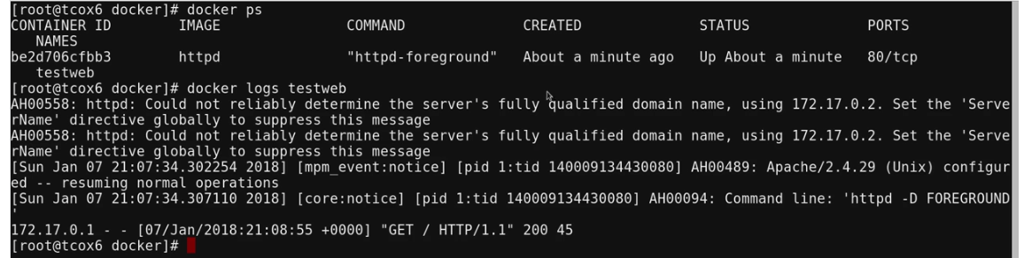

To setup syslog as default logging mechanism,



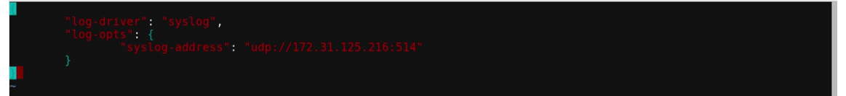

Make sure you restart docker for the effect to make change

Now logs are recored in the /var/log/message

To change the logging system for the individual container on container run,



Total Time 18 minutes

## Lecture: Setting Up Swarm (Configure Managers)

This is the first step to making a Docker Swarm available for use. Let's configure our first Swarm Manager and learn how to display the commands and tokens for joining other managers and workers to our cluster.

To initialize docker swarm on a particular Host node Ip

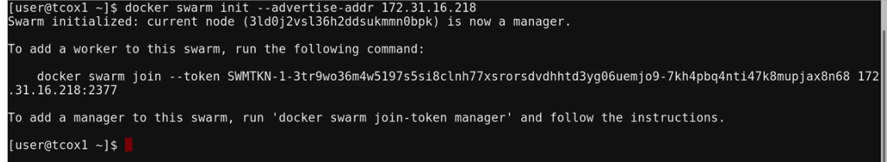

One may need to copy the token so that one may add a worker to the swarm.

However to redisplay the token,

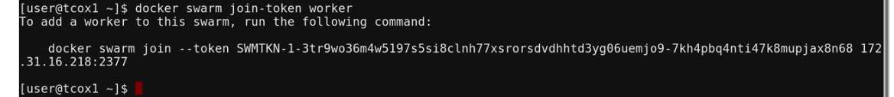

To create another manager,

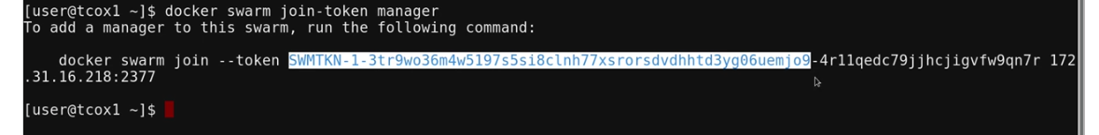

To create another worker,



Total Time 8 minutes